Project Synopsis

Project Title:

Property Management App – An Automated Property and Rent Management System
Domain: Android Application Development
Platform: Android Studio (Java, XML)
Database: Firebase Realtime Database & Firebase Storage

1. Introduction
Property Management App is a modern Android-based application designed to streamline daily transactions and communication between landlords and tenants. Traditional manual record-keeping methods are often complex, time-consuming, and prone to errors. This application provides property owners (admins) with a digital platform where they can efficiently manage multiple properties, tenants, rent collections, and maintenance requests from a single interface.

2. Problem Statement
In manual property management systems, landlords face several challenges:
- Payment Tracking: Managing rent payments received from different tenants through various modes such as Cash, UPI, Card, and Cheque becomes difficult.
- Data Security: Physical records and registers may be lost, damaged, or misplaced.
- Payment Verification: Storing and managing payment proof such as UPI screenshots or cheque images for future reference is challenging.
- Communication Gap: There is no centralized platform for handling maintenance requests, reminders, and communication between landlords and tenants.

3. Objectives
The primary objectives of this project are:
- To make the rent collection process fully digital and transparent.
- To provide automated validation and secure storage of payment proofs for different payment modes (Cash, UPI, Card, and Cheque).
- To securely store all property and tenant information on the cloud using Firebase.
- To provide landlords with a dashboard displaying financial insights such as rent status, pending payments, and occupancy information.

4. System Architecture and Modules

A. Admin Module (Landlord)
- Dashboard: Displays an overview of total tenants, total rent collected, pending rent, and maintenance request status.
- Tenant Management: Add new tenants, assign rent amounts, and manage tenant profiles.
- Rent Recording: Update rent status (Paid/Unpaid). When UPI or Cheque is selected as the payment mode, the application requires image proof for verification.
- Property Insights: View room occupancy status and identify vacant or occupied properties.

B. Tenant Module
- Payment History: View records of all previous rent payments.
- Due Alerts: Check upcoming rent due dates and payment status.
- Maintenance Portal: Submit maintenance requests such as plumbing, electrical, or other property-related issues directly to the landlord.

C. Data Security and Storage
- Firebase Authentication: Provides a secure user login and authentication system.
- Firebase Storage: Stores UPI screenshots and cheque images securely in the cloud for future verification.

5. Technical Stack (Tools and Technologies)
- Operating System: Android (Minimum SDK 24+)
- Integrated Development Environment (IDE): Android Studio
- Programming Languages:
  - Frontend: XML with Material Design 3
  - Backend: Java (Android SDK)
- Database: Firebase Realtime Database (NoSQL)
- Cloud Storage: Firebase Storage
- External Libraries:
  - Glide (Image Loading)
  - MPAndroidChart (Reports and Analytics)

6. Unique Features of Property Management App
- Multi-Mode Payment Proof Verification: Rent is not only marked as paid, but UPI screenshots or cheque images are also uploaded and stored, ensuring financial transparency and verification.
- Real-Time Cloud Synchronization: All data is stored in Firebase, allowing users to access records even after changing devices.
- Modern User Interface: A clean, professional, and dark-themed interface designed to enhance the overall user experience.

7. Future Scope
- Payment Gateway Integration: Enable tenants to make rent payments directly through the application using UPI, net banking, or other digital payment methods.
- Automated Notifications: Send automatic rent reminders through WhatsApp or SMS before the due date.
- Rental Agreement Management: Generate rental agreement PDFs and support digital signatures within the application.

Use Case Diagram (Functionality Overview)

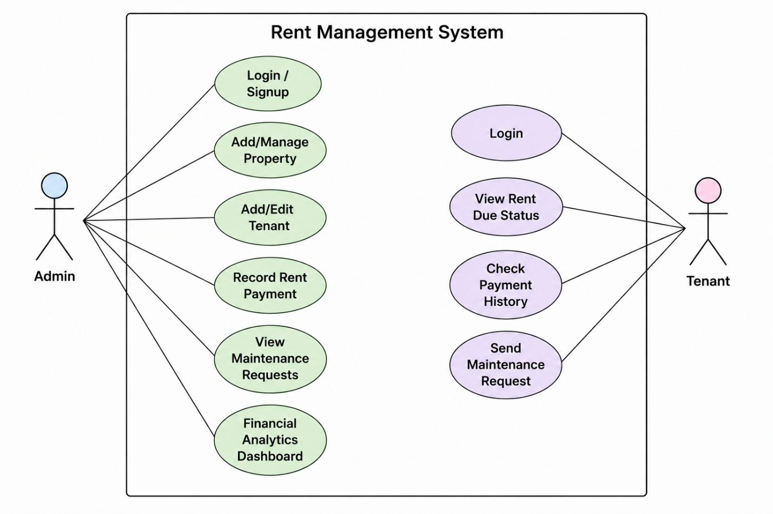

Flowchart: Record Rent Process (Logic Flow)

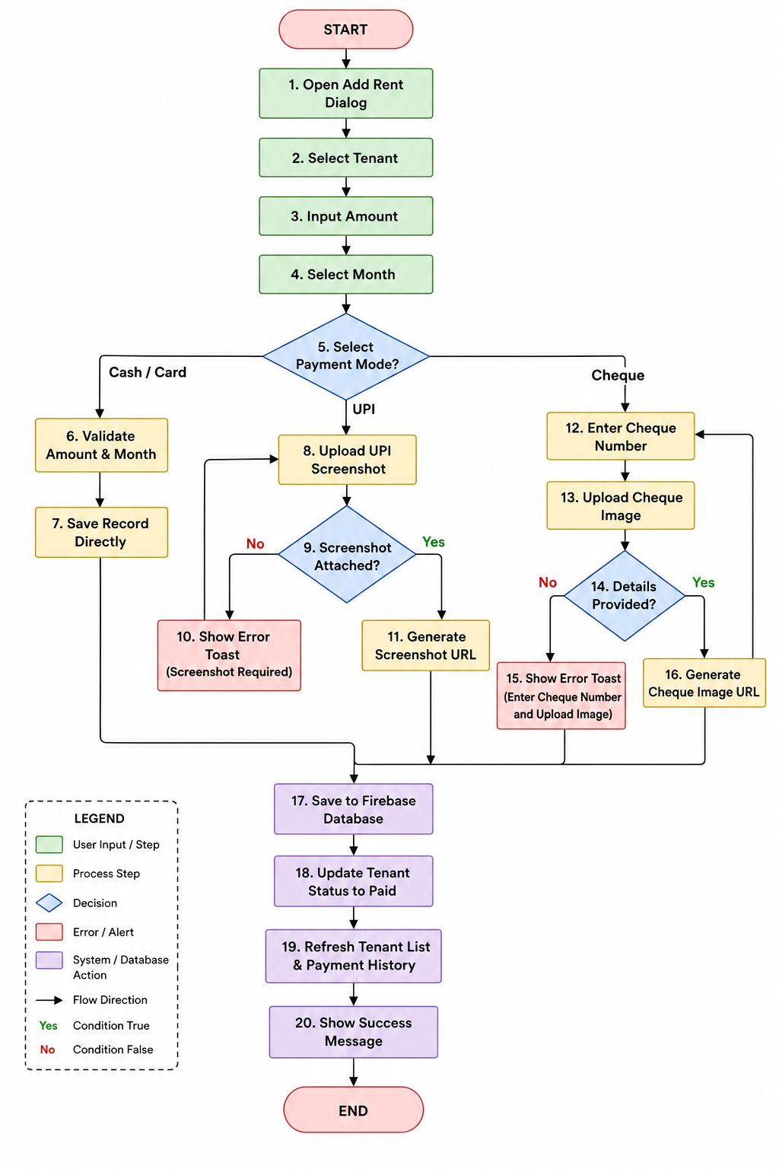
ER Diagram (Database Structure)
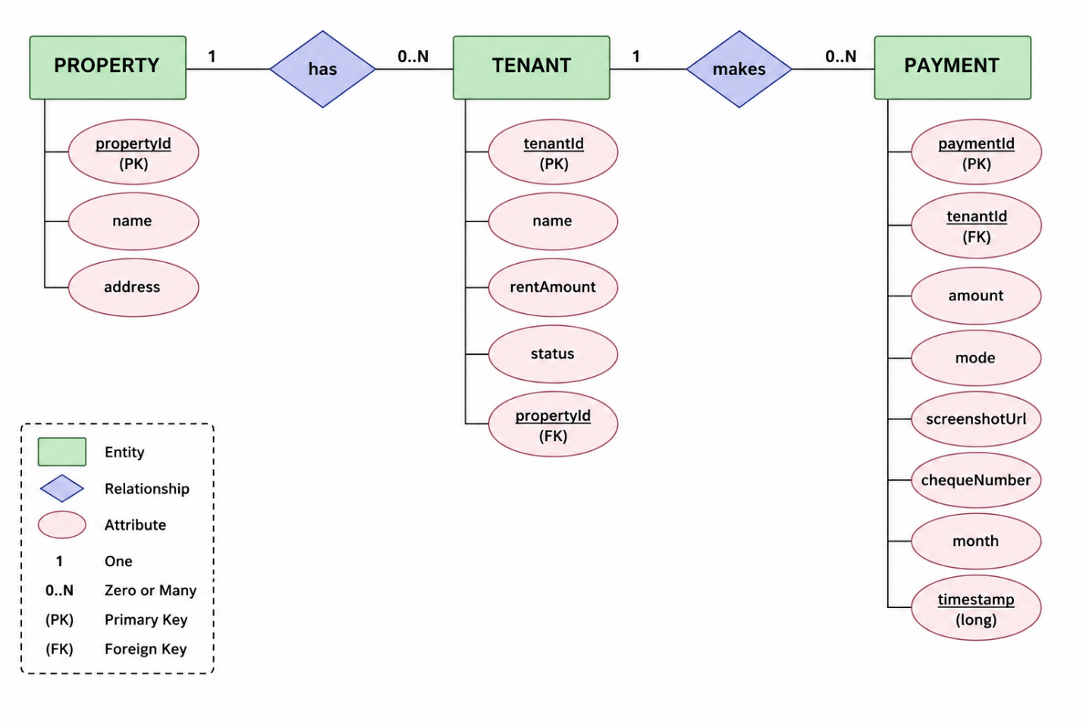

8. Conclusion
Property Management App transforms traditional property and rent management into a modern, efficient, and professional digital solution. The application saves time, improves record accuracy, and enhances transparency and trust between landlords and tenants. With secure cloud storage and multi-mode payment verification, Property Management App provides a reliable and robust platform for effective property management.

